Chapter 5, Problem 71

Determine v_{o} in the op amp circuit in Fig. 5.97.

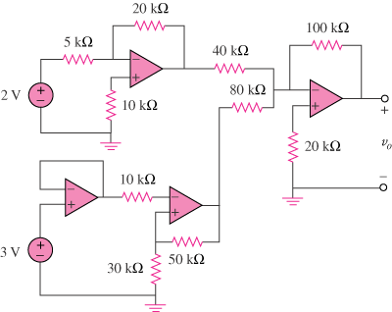
+
–
1.5 V
2.25 V

Figure 5.97
For Prob. 5.71.

